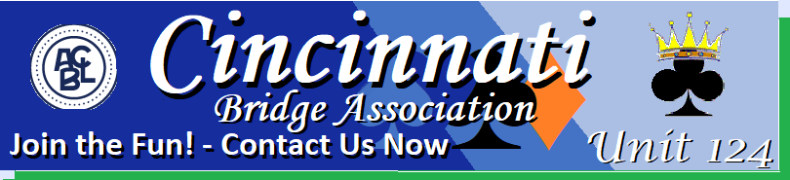
SPRING FLING
NonLife Master Silverpoint Sectional
April 26-28 2024
Cincinnati Bridge Center
2860 Cooper Road
Cincinnati, Ohio 45241

Friday and Saturday 10 AM and 2:30 PM
Two Single Sessions
Lunch Served between Sessions
Sunday 10 am
Stratified Swiss Play Thru
Lunch Provided

Stratifications 0-100 C 101-300 B 300-500 A
All strats by average points-adjustments may be made by director for best stratification.
Entry Fee for all Sessions $15/per player
Hotel information available from the Partnership Chair (no designated hotel)
Partnerships Tournament Chair
Terry and Jim Barrett Bill Brewer
513-504-1094 513-255-7240
cincibridgecenterdirectors@gmail.com brewerwe@miamioh.edu

